Design & Implementation

Gateway
The system’s point of contact to the internet is the gateway, this connects all smaller devices to the necessary databases, frameworks, and libraries. Some configuration is done first. The operating system’s image used, Raspbian, is installed on a micro SD card as per:
- Raspbian Stretch (Debian 9) is downloaded and copied to the micro SD card inserted in a laptop using the Balena Etcher tool.
- The copied image is inserted into the RP3 and the operating system is installed.
- RP3 is connected to a monitor where Secure Shell (SSH) is enabled on the device, then a Wi-Fi connection is established and the IP address is noted.
SSH allows a user to boot into a remote machine by passing just the IP address of that machine to the SSH command on the command line, all needed now for the RP3 is power. Linux’s package manager, apt, is used to ensure the system is current; the commands below checks the device’s package repositories and downloads and installs new ones if available.

user@laptop:~$ sudo apt-get update

user@laptop:~$ sudo apt-get upgrade

All subsequent apt repositories added are done with the below bash command:

user@laptop:~$ sudo add-apt-repository ppa:SomeRepo/ppa

Peak Detection
This section of the report will analyse the recorded data and return the global maxima, the nationwide demand supplied by EirGrid will be used as a prototype. All Python libraries are installed with Python’s package manager, pip, using the following command:

user@laptop:~$ pip3 install my_pip_pkg # For Python version 3.x

Pandas
Data supplied by air grid is in comma-separated values format, the spreadsheet has two usable columns, DateTime and demand, DateTime comes in the form of the date recorded followed by the time, the demand column is measured in Watts. To load data into a Python script, Pandas’ read_csv function is used. The first parameter is the resource, the second parameter is how each value is separated, the third is missing values, to prevent data corruption like null or inappropriate values being grouped together like the second row in Table scjbakbjs.
DATE & TIME | ACTUAL DEMAND(MW)
00:45:00 | 3464
01:00:00 | -

raw_csv = pd.read_csv('my_csv.csv', sep=',', na_values=missing_values)

Pandas supplies another intelligent data cleaning function which selects all rows in the column name passed to the function, these functions can convert to numeric, string, or datetime objects.

date_s = pd.to_datetime(raw_csv['DATE'])

demand_series = pd.to_numeric(raw_csv['DEMAND'])

The lines above return two DataFrames, one with all times recorded, the other with the demand at those times.
Pandas allows the day of the recording to be accessed using the DateTime library, this further narrows the range of values to a specific day passed:

day = date_series.dt.day

This dataframe can be checked and upon match can be appended at the timestamp’s index of match to a standard Python list using another Pandas function called iloc, returning the demand value at the passed index.

demand_needed = []

for idx, d in day.iteritems():

if d == date_chosen.day:

demand_needed.append(demand_s.iloc[idx])

This list is comprised of string values, to use mathematically these values must be converted to integer ones using Numpy’s function array, Python’s map, and pass the type. This list is passed to PeakUtil’s indexes function, the second parameter is the threshold, 0.8 indicates 80% of maximum, the third specifies the minimum distance between the peaks, this limits the number of peaks detected. This function only returns the indexes, not the peaks themselves.

demand_needed = np.array(list(map(int, demand_needed)))

peak_times = peakutils.indexes(demand_needed, thres=0.8, min_dist=10)

Finding the demand across that day is done by passing the peak times as indexes and appending to a list, Numpy’s mean function is called to return the average across that list.

peak_val = [] # stores the peaks

for idx, j in enumerate(peak_times):

peak_val.append(demand_needed[j]) # the demands at the given indexes

peak_avg = np.mean(peak_val)

DO MATHS for PEAK AVG
The peak demand is found across a particular day. To define a threshold for peak detection, any value within 5% of the peak average is counted. Current demand is compared with the defined threshold, if less than or equal, the function returns true, this can then manipulate a device states based on current demand compared to historical.

thresh = peak_avg - peak_avg/20

if demand >= thresh:

return True

else:

return False

Persistence
The collected data is stored somewhere accessible to the internet and for future use. InfluxDB is installed with the RP3, via apt and pip, the former for general querying and pip for use in Python.

user@laptop:~$ sudo apt install influxd && apt install influx

user@laptop:~$ pip3 install influxdb

Starting Influx requires the daemon to be started first which can be run in the background, the Influx console can now be accessed and a database can be created.

user@laptop:~$ sudo influx& # &: process is not seen in terminal

user@laptop:~$ sudo influx

To provide data security, users can be added to a database by enabling authentication in the Influx config file and adding a username and password in an HTTP query:

curl -XPOST "http://localhost:8086/query" --data-urlencode "q=CREATE USER admin WITH PASSWORD 'passwd' WITH ALL PRIVILEGES"

Creating and using a database is done within the Influx console using the Influx Query Language (IQL), this is now available at RP3’s IP at port 8086:

CREATE DATABASE new_db

USE new_db

Data insertion and querying may be done from Python now. Querying data involves the IQL command below, which selects power values from Node 0 & 1:

SELECT "node0","node1" FROM "watts"

Points can be inserted into the database with the Influx DB client offered by pip, measurements, fields, and tags must influence the database design to minimise complexity. Two field types will be used, one for value, one for device state, the measurement represents units of the value, and tags can be used for the node number. A separate script has been written, the recorded data can be written to the database, the script can be accessed like any pip library function in JSON format:

points = [{

"measurement": units,

"fields": "Value": value, "Dev State": d_state,

"tags": "Node": node

}

]

i_client.write_points(points)

Plug Connection
Connecting the plug to the gateway requires OZW using a virtual environment to isolate the script’s libraries from the native ones, where the UZB can receive polls from nodes.

Hardware
The Z-wave controller is connected by a serial port on the gateway, Linux allows devices to be accessed as if a directory or file; A device is located in the /dev folder, this device can now be accessed using commands like ls, which shows all resources available in a directory:

user@laptop:~$ sudo ls /dev/tty*

tty is where all USB devices are available, the asterisk is to show all devices, finding the Z-wave device can be done by running the command before inserting the USB and running after to compare. The Z-wave smart plug is inserted into a socket and the action button can be used to initiate pairing mode. The load is then inserted into the smart plug and code is ran. may not exceed 3000 Watts.

Software
The access of the device’s registers is done through the OZW library and Z-wave signals are access using the dispatcher, Python modules were written to facilitate data processing and included in the main file, m_test.py:

import influx_insert as in_is

import peak_shave as ps

Collection
OZW’s network class has signals that indicate the state of the network, the network can be started and connected via the dispatcher.

dispatcher.connect(louie_network_ready, ZWaveNetwork.SIGNAL_NETWORK_READY)

ZWaveNetwork.SIGNAL_NETWORK_AWAKED

Collecting data begins when the network is ready with the following condition:

if network.state>=network.STATE_READY:

Accessing each node is done by iterating through the nodes class inside the Z-wave instance, reading the all sensors is similar with the val being the sensor register location in decimal format.

for node in network.nodes:

for val in network.nodes.get_sensors():

For each sensor the returned value will be passed to the influx_write function, with a check on the variable type to ensure only float values are inserted into the database, type non-uniformity causes is not permitted.

t_val = network.nodes.get_sensor_value(val)

if type(t_val) is float:

in_is.influx_write(

network.nodes.values[val].units,

t_val,

network.nodes.get_sensor_value(state),

node)

Comparing the current demand to that over the day is achieved by gneratating a Pandas DataFrame from the database by calling the to_panda function, implementation is below:

this_hour = in_is.to_panda() # called in m_test.py

pd_frame = pd.DataFrame(influx_q('SELECT "Value" FROM W WHERE time > now() - 1d'))

The day demand as a list, is passed to the peak checking function and a boolean is returned.

ps.is_peak(this_hour, network.nodes[node].get_sensor_value(W))

Based on this result, the state of the plug is changed.
The Z-wave plug device does not allow for polling to be enabled, resulting in a network restart on every read, the terminal output is flushed also.

sys.stdout.flush()

network.stop()

Visualisation
Grafana accesses InfluxDB and uses its tools to visualise the data on an online tool available at port 3000. Grafana is installed with apt below.

user@laptop:~$ sudo apt-get install grafana
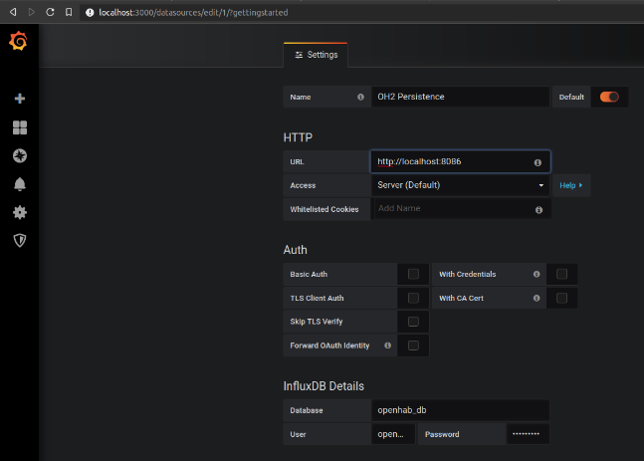
It is accessed on the browser with the default username and password, admin and password, respectively. The database is added as a source at the IP and port number location, localhost:8086, users are added to that source.

Querying and graphing is done through the dashboard, where a graph is added, and constraints are selected.
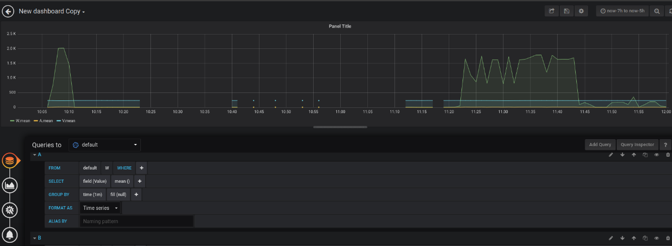

OpenHAB Control
OpenHAB2 (OH2) runs on Java, therefore, it too is installed below.

user@laptop:~$ sudo apt-get install oracle-java8-jdk && apt-get install openhab2

Installing on Raspbian requires some additional configuration; the file system is expanded and the GPU-CPU memory split to 16MB using the RP3 config. The following line is added to OH2’s configuration.

user@laptop:~$ sudo raspi-config

EXTRA_JAVA_OPTS="-Dgnu.io.rxtx.SerialPorts=dev/ttyACM0" # /etc/default/openhab2

After a restart, the OH2 is available at port 8080 on a browser, here bindings are added, then, things and channels. Enabling bindings is done below along with OH2 ran on boot.

user@laptop:~$ sudo apt-get install openhab2-addons && systemctl enable openhab2.service

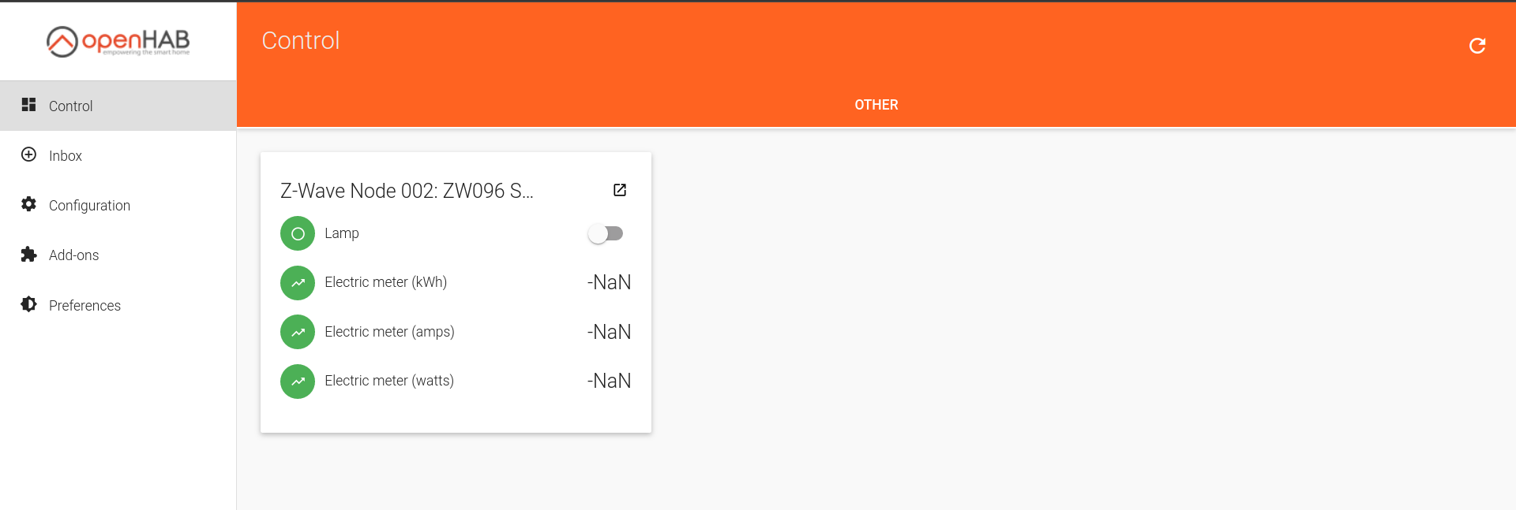
The Z-wave binding is added to the dashboard along with the controller and plug. The controller is added within the binding by passing the serial port. When both UZB and plug are in pairing mode, the node (plug) is added to the network.

Channels are added to the node (thing in OH2), some can monitor the demand and energy while the other is used to control the previously mentioned.

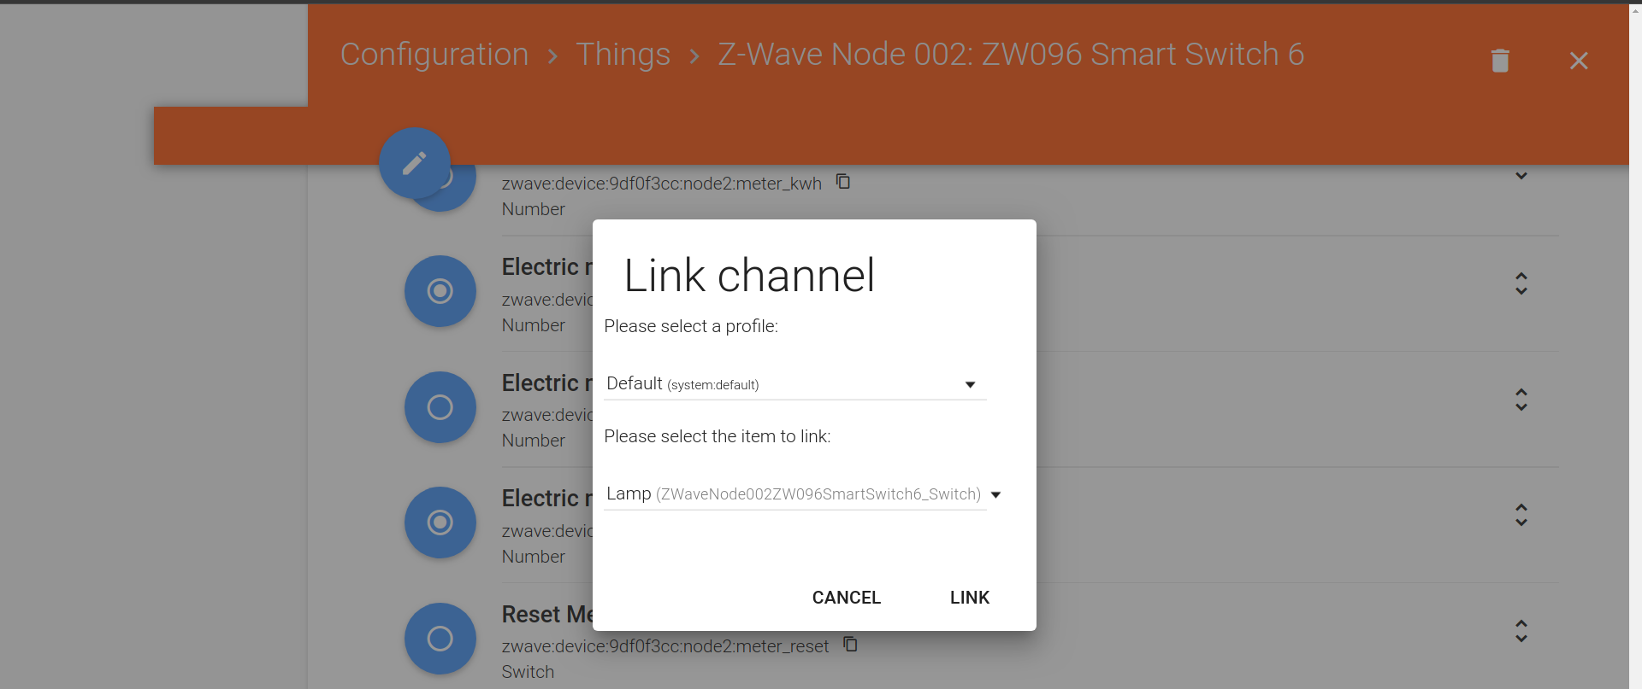
The Watts channel is updated upon each poll and the switch controls the state of the plug.

Device Write
Finding command class
Write upon peak

References

